**Environmental settings**

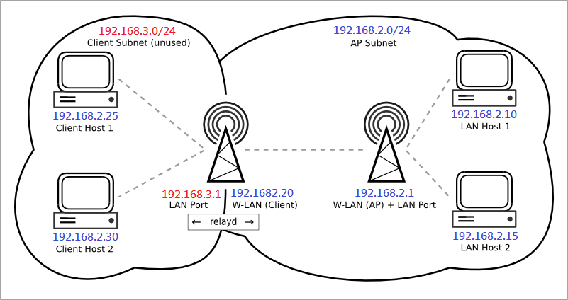

**AP mode board**:

FW: openwrt-ramips-mt7620-Multicast-AP_mode-20180515.bin

Web GUI IP: 192.168.2.1 (it has a DHCP server)

Setting steps:

1. Update FW (disable "Keep settings")

2. Modify wlan channel (use console or telnet)

     2.1 open file /etc/config/wireless

     2.2 modify "option channel 0" --> "option channel 6"

3. reboot

**Client mode board**:

FW: openwrt-ramips-mt7620-Multicast-Client_mode-20180531.bin

Web GUI IP: 192.168.3.1

Setting steps:

1. Update FW (disable "Keep settings")

2. Modify AP SSID name (use console or telnet)

     2.1 open file /etc/init.d/apclient

     2.2 modify SSID

3. reboot

**Factory to default**

You need to use Ethernet network wire connect it.

**From Web GUI:**

AP mode board:   
a. Browser connected to 192.168.2.1  
b. login -> System -> Backup / Flash Firmware

Client mode board:   
 a. The connected computer needs to be set to 192.168.3.x  
 b. Browser connected to 192.168.3.1  
 c. login -> System -> Backup / Flash Firmware

**From Telnet:**

AP mode board:   
a. telnet to 192.168.2.1  
b. > firstboot

y  
 > reboot

Client mode board:   
a. The connected computer needs to be set to 192.168.3.x  
b. telnet to 192.168.3.1  
c. > firstboot

y  
 > reboot

**From Serial port:**

Serial port setting: Baud rate 57600, 8N1

> firstboot

y

> reboot